

**MINI PROJECT**

**DOMAIN NAME: JAVA**

**GOLD MONITORING SYSTEM**

**Submitted By:-**

Neel Rayal (18162121028)

Krutik Shah (18162121035)

Aniket Roy (18162121029)

II Year – (BDA) ‘B’ Section

Ganpat University, Ahmedabad



**Submitted To:-**

A. Saai Sanjeev Achaarya

IBM Software Technical Trainer

**FLOW CHART**

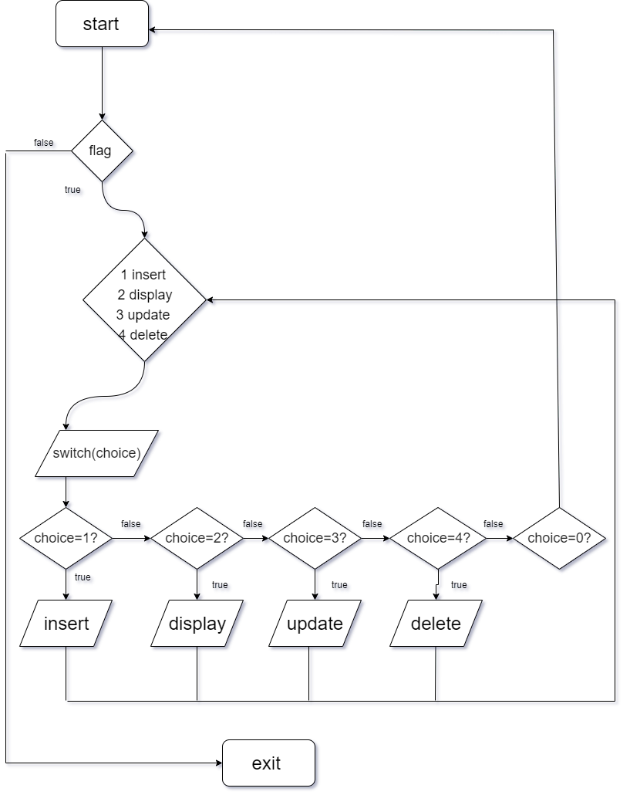

**SOFTWARE SPECIFICATIONS**

* OPERATING SYSTEM : Linux / Windows
* ENVIRONMENT :

Community Edition

**HARDWARE SPECIFICATIONS**

|  |  |  |
| --- | --- | --- |
| * PROCESSOR | : | Intel(R) Core(TM) i3-7020U CPU @ 2.30 GHz 2.30GHz |
| * RAM | : | 8GB SD RAM |
| * HARD DISK | : | 1 TB |
| * FLOPPY DRIVE | : | 1.44 MB |
|  |  |  |

**DESCRIPTIONS:**

**INTRODUCTION:**

The GOLD RATE MONITORING SYSTEM is simply a system for monitoring the gold rates in the market and provide details about gold rates and sales reports

**DESCRIPTION:**

It is the project which aims in:

* Safe and secure buying – selling of gold
* Keeping records of sales by an individual seller and purchase by an individual consumer
* To provide real time gold rates in the market

It is managed by the admin to maintain the data records of individual seller and buyers such as gold purchased by a consumer, gold sold by a seller, etc.

**PROS:**

1. For better monitoring of gold sales – purchases and management
2. This can replace physical data like paperwork as physical data can be destroyed in disasters and accidents
3. Easing of tax filing and data management
4. Prevent frauds by seller like illegal selling (Overcharging through false hidden charges)
5. This monitoring system provides freedom to both the shop owner and customer, This provides a trustless environment

**CONS:**

1. The owners cannot cheat the customers as the current rate is available to them.
2. The major downside of this system is for the jewelry store oweners.When the price of gold go downs the customers can may buy gold in huge amount which may incur a huge loss to the owners.
3. If the servers are not responding the trade may not be possible.

**GOLD MONITORING SYSTEM**

**AIM:**

**To implement the java program for Online Campus Placement System which as:-**

* **Home page and Login page**
* **Gold Rate and Cart of gold**
* **Sales report and display the gold rate**

**JAVA PROGRAM:-**

import java.util.Scanner;  
  
class Entry  
{  
private String Name,City,ShopName;  
private int PhoneNumber,Age;  
Scanner reader = new Scanner(System.in);  
public void set_name()  
{  
System.out.println("Enter your name");  
Name = reader.nextLine();  
}  
public void set_ShopName()  
{  
System.out.println("Enter your shop name");  
ShopName = reader.nextLine();  
}  
public void set_City()  
{  
System.out.println("Enter your city");  
City = reader.nextLine();  
}  
public void set_PhoneNumber()  
{  
System.out.println("Enter your Phone Number");  
PhoneNumber = reader.nextInt();  
reader.nextLine();  
}  
public void set_Age()  
{  
System.out.println("Enter your Age");  
Age = reader.nextInt();  
reader.nextLine();  
}  
  
public String get_name()  
{  
return this.Name;  
}  
  
public String get_ShopName()  
{  
return this.ShopName;  
}  
public String get_City()  
{  
return this.City;  
}  
public int get_PhoneNumber()  
{  
return this.PhoneNumber;  
}  
public int get_Age()  
{  
return this.Age;  
}  
  
public void Display()  
{  
System.out.println("Name is: " + get_name());  
System.out.println("Shop Name is: " + get_ShopName());  
System.out.println("City is: " + get_City());  
System.out.println("Phone Number is: " + get_PhoneNumber());  
System.out.println("Age is: " + get_Age());  
}  
}  
  
  
class project extends Entry  
{  
public static void main(String[] args)  
{  
int choice,count = 0;  
boolean flag = true;  
Entry obj[] = new Entry[10];  
while(flag)  
{  
Scanner reader = new Scanner(System.in);  
System.out.println("Enter your choice: ");  
System.out.println("1. Insert Records");  
System.out.println("2. Display Records");  
System.out.println("3. Update Records");  
System.out.println("4. Delete Records");  
System.out.println("0. Exit");  
choice = reader.nextInt();  
switch(choice)  
{  
case 0:  
{  
System.out.println("Bye\n");  
flag = false;  
break;  
}  
case 1:  
{  
Insert(count,obj);  
count++;  
break;  
}  
case 2:  
{  
Display(count,obj);  
break;  
}  
case 3:  
{  
Update_Records(count,obj);  
break;  
}  
case 4:  
{  
Delete_Entry(count,obj);  
break;  
}  
default:  
{  
System.out.println("Enter a valid value\n");  
}  
}  
}  
  
  
}  
public static void Insert(int count,Entry obj[])  
{  
Scanner reader = new Scanner(System.in);  
obj[count] = new Entry();  
obj[count].set_name();  
obj[count].set_Age();  
obj[count].set_PhoneNumber();  
obj[count].set_ShopName();  
obj[count].set_City();  
}  
public static void Display(int count,Entry obj[])  
{  
Scanner reader = new Scanner(System.in);  
String temp_name;  
System.out.println("Enter the name to display it's details: ");  
temp_name = reader.nextLine();  
boolean flag = false;  
for(int i=0; i<count; i++)  
{  
if(obj[i].get_name().equals( temp_name))  
{  
obj[i].Display();  
flag = true;  
break;  
}  
else if(obj[i] == null)  
{  
System.out.println("Name not found");  
}  
}  
if(! flag)  
System.out.println("Name not found");  
}  
public static void Update_Records(int count,Entry obj[])  
{  
Scanner reader = new Scanner(System.in);  
String temp_name;  
System.out.println("Enter the name to to update it's entry: ");  
temp_name = reader.nextLine();  
int flag = 0;  
for(int i=0; i<count; i++)  
{  
if(obj[i].get_name().equals( temp_name))  
{  
System.out.println("What do you want to update?");  
boolean flaggy = true;  
while(flaggy)  
{  
System.out.println("1. Name\n2. ShopName\n3. City\n4. Age\n5. PhoneNumber\n0. Exit");  
int temp = reader.nextInt();  
switch(temp)  
{  
case 0:  
{  
flaggy = false;  
break;  
}  
case 1:  
{  
obj[i].set_name();  
break;  
}  
case 2:  
{  
obj[i].set_ShopName();  
break;  
}  
case 3:  
{  
obj[i].set_City();  
break;  
}  
case 4:  
{  
obj[i].set_Age();  
break;  
}  
case 5:  
{  
obj[i].set_PhoneNumber();  
break;  
}  
  
}  
}  
flag = 1;  
break;  
}  
}  
if(flag == 0)  
System.out.println("Name not found");  
}  
  
public static void Delete_Entry(int count,Entry obj[])  
{  
Scanner reader = new Scanner(System.in);  
String temp_name;  
System.out.println("Enter the name to to delete it's entry: ");  
temp_name = reader.nextLine();  
int flag = 0;  
for(int i=0; i<count; i++)  
{  
System.out.println(obj[i].get_name());  
if(obj[i].get_name().equals( temp_name))  
{  
obj[i] = null;  
System.out.println("Deleted Successfully");  
flag = 1;  
break;  
}  
}  
if(flag == 0)  
System.out.println("Name not found");  
}  
  
}

**OUTPUT:**

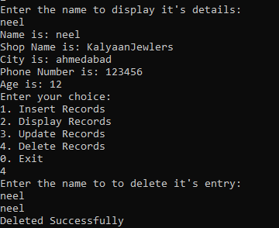

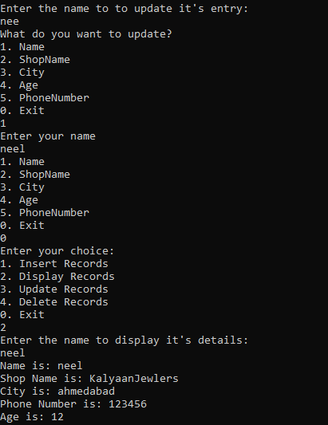

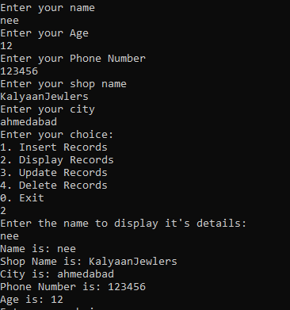

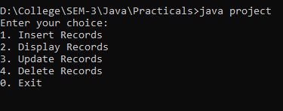

**HTML PROGRAM:-**

<!DOCTYPE html>

<html>

<head>

<link rel="shortcut icon" href="gold.jpeg" type="image/x-icon">

<title>Webpage</title>

<link rel="stylesheet" type="text/css" href="container.css">

</head>

<body>

<div class="container">

<div class ="navigation">

<div class ="title">

<a href="About.html">

<img src="ict.png" style="width:15%">

</a>

<ul class ="nav">

<li><a href="About1.html" target="_blank"> <font color="Black">About</font></a></li>

<li><a href="Contactus1.html" target="_blank"> <font color="Black">Contact</font></a></li>

<li><a href="Signin.html" target="_blank"> <font color="Black">SignIN</font></li>

<li><a href="Signup.html" target="_blank"> <font color="Black">SingUP</font></a></li>

</ul>

</div>

</div>

<div class="footer">

</p>

</div>

</div>

</div>

</body>

</html>

**OUTPUT:**

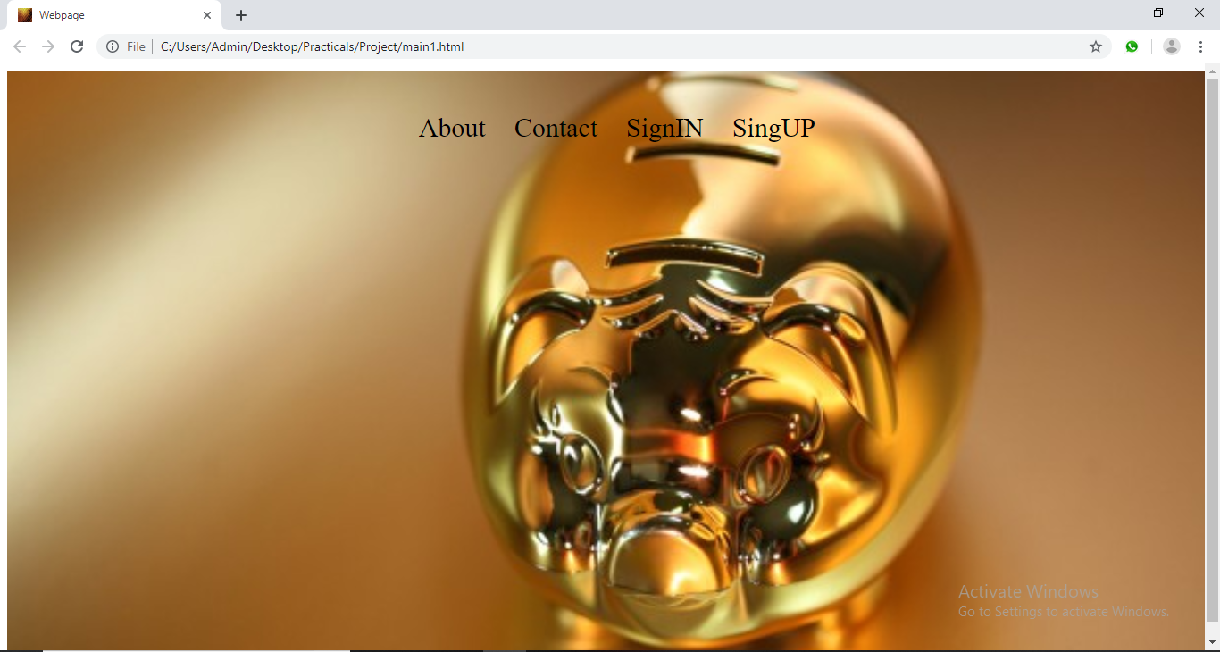

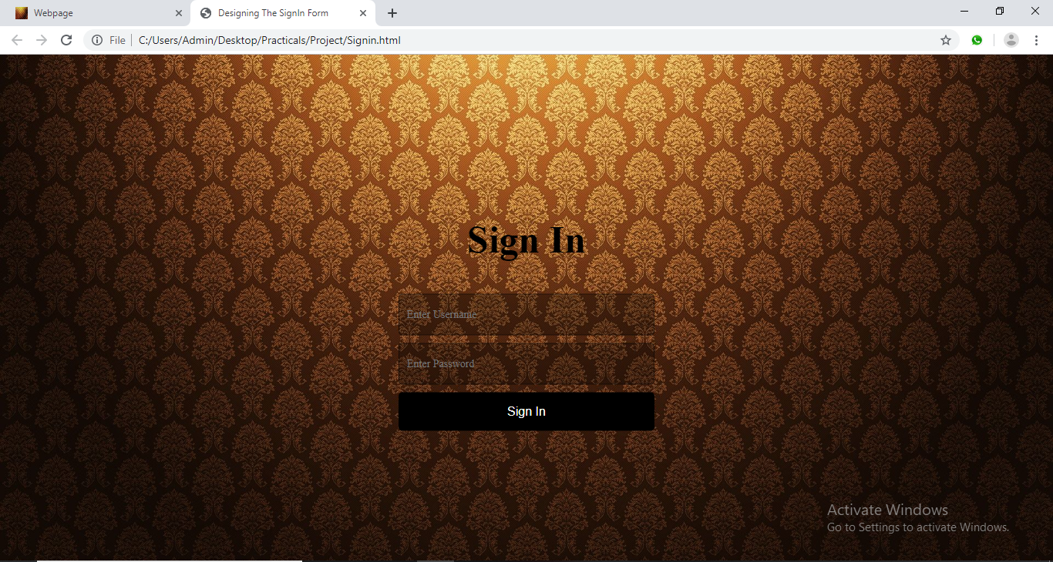

**EXPLANATION ABOUT PROJECT:**

**This project has three modules:**

**1)User login, User details: -**

Login page prompts the user to enter their details which will be saved in the database.

**Home page and Login page**

Customers or Jewlry owner’s have to login in their account and the current rate of gold will be shown on the home page of this web-app.

**2) Gold Rate and Rate of gold**

The current gold rate will be displayed on the home page and rate of gold will be decided with the help of API’s.

**3)Sales report and display the gold rate**

The current rate of gold in the market will be available to everyone and the web app will display Sales report with the previous history of transcitions. The Sales report will display the growth or slump as per the history of transcitions.

**OUTPUT SCREENSHOTS:**













**REFRENCES:**

1. Google Images
2. w3schools

**CONCLUSION:**

Thus,we conclude that the better way to easily monitoring the price of Gold.User can easily get daily updates of frequently changes in the price of Gold.